**LABCYCLE 1**

**DATE : 01/06/21**

**EXPERIMENT NO : 1**

**AIM : Write a java program to display a message ‘Welcome to Java Programming’.**

**SOURCE CODE :**

class Hello

{

public static void main(String args[])

{

System.out.println("welcome to java programming");

}

}

**RESULT :**

**Program was successfully compiled, executed and result obtained.**

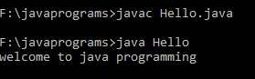

**DATE : 01/06/21**

**EXPERIMENT NO : 2**

**AIM : Create a class ‘Rectangle’ with instance variables length and breadth. Define a**

**method ‘setData’ for setting the values of instance variables and a method ‘getArea’**

**to return the area of a Rectangle. Using this class to find out the area of the following**

**Rectangles.**

|  |  |  |
| --- | --- | --- |
| **Rectangle** | **Length** | **Breadth** |
| **R1** | **12.4** | **13** |
| **R2** | **10.5** | **9** |
| **R3** | **13** | **14** |

**SOURCE CODE :**

class Rectangle

{

float length,breadth;

void setData(float l,float b)

{

length=l;

breadth=b;

}

void getArea()

{

float area=length*breadth;

System.out.println("Area= "+area);

}

}

class RectangleArea

{

public static void main(String args[])

{

Rectangle r1=new Rectangle();

r1.setData(12.4f,13f);

r1.getArea();

r1.setData(10.5f,9f);

r1.getArea();

r1.setData(13f,14f);

r1.getArea();

}

}

**RESULT :**

**Program was successfully compiled, executed and result obtained.**

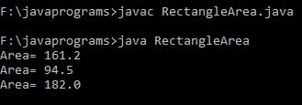

**DATE : 01/06/21**

**EXPERIMENT NO : 3**

**AIM : Write a java program to read an integer from keyboard and check whether the number**

**is odd or even.**

**SOURCE CODE :**

import java.util.*;

class CheckOddorEven

{

public static void main(String args[])

{

Scanner sc=new Scanner(System.in);

System.out.println("Enter two integers");

int num1=sc.nextInt();

int num2=sc.nextInt();

if(num1%2==0)

{

System.out.println(num1+"is an even number");

}

else

{

System.out.println(num1+"is an odd number");

}

if(num2%2==0)

{

System.out.println(num2+"is an even number");

}

else

{

System.out.println(num2+"is an odd number");

}

}

}

**RESULT :**

**Program was successfully compiled, executed and result obtained.**

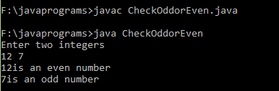

**DATE : 01/06/21**

**EXPERIMENT NO : 4**

**AIM : Write a java program to read 2 matrices from the console and perform matrix**

**addition.**

**SOURCE CODE :**

import java.util.*;

class MatrixAdd

{

public static void main(String args[])

{

Scanner sc=new Scanner(System.in);

System.out.println("Enter Rows and column of the matrix \n");

int m=sc.nextInt();

int n=sc.nextInt();

int i,j;

int A[][]=new int[m][n];

int B[][]=new int[m][n];

int sum[][]=new int[m][n];

System.out.println("Enter elements to matrix A one by one \n");

for(i=0;i<m;i++)

{

for(j=0;j<n;j++)

{

A[i][j]=sc.nextInt();

}

}

for(i=0;i<m;i++)

{

for(j=0;j<n;j++)

{

B[i][j]=sc.nextInt();

}

}

System.out.println();

//adding and printing addition of 2 matrices

for(i=0;i<m;i++){

for(j=0;j<n;j++){

sum[i][j]=A[i][j]+B[i][j];

System.out.print(sum[i][j]+" ");

}

System.out.println();

}

}

}

**RESULT :**

**Program was successfully compiled, executed and result obtained.**

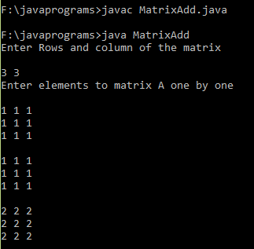

**DATE : 01/06/21**

**EXPERIMENT NO : 5**

**AIM :** Write a java program to read a matrix from the console and check whether it is

symmetric or not.

**SOURCE CODE :**

import java.util.Scanner;

public class SymmetricMatrixProgram

{

public static void main(String[] args)

{

Scanner sc = new Scanner(System.in);

System.out.println("Enter the no. of rows : ");

int rows = sc.nextInt();

System.out.println("Enter the no. of columns : ");

int cols = sc.nextInt();

int matrix[][] = new int[rows][cols];

System.out.println("Enter the elements :");

for (int i = 0; i < rows; i++)

{

for (int j = 0; j < cols; j++)

{

matrix[i][j] = sc.nextInt();

}

}

System.out.println("Printing the input matrix :");

for (int i = 0; i < rows; i++)

{

for (int j = 0; j < cols; j++)

{

System.out.print(matrix[i][j]+"\t");

}

System.out.println();

}

//Checking the input matrix for symmetric

if(rows != cols)

{

System.out.println("The given matrix is not a square matrix, so it can't be symmetric.");

}

else

{

boolean symmetric = true;

for (int i = 0; i < rows; i++)

{

for (int j = 0; j < cols; j++)

{

if(matrix[i][j] != matrix[j][i])

{

symmetric = false;

break;

}

}

}

if(symmetric)

{

System.out.println("The given matrix is symmetric...");

}

else

{

System.out.println("The given matrix is not symmetric...");

}

}

sc.close();

}

}

**RESULT :**

**Program was successfully compiled, executed and result obtained.**

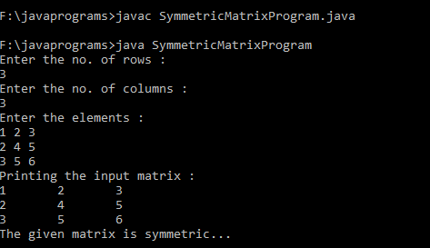

**DATE : 01/06/21**

**EXPERIMENT NO : 6**

**AIM : Define a class ‘product’ with data members’ pcode, pname and price. Create 3 objects**

**of the class and find the product having the lowest price.**

**SOURCE CODE :**

**RESULT :**

**Program was successfully compiled, executed and result obtained.**

**DATE : 01/06/21**

**EXPERIMENT NO : 4**

**AIM :**

**SOURCE CODE :**

**RESULT :**

**Program was successfully compiled, executed and result obtained.**